**1) Windows**

* Download CodeBlocks from: <http://www.codeblocks.org/downloads/binaries/>

The file is: *codeblocks-20.03mingw-setup.exe*

* Install the code and after installation open the programm,

* First check if the C++ compiler is selected, for that go to: Settings -> Compiler…

A window like this will be open

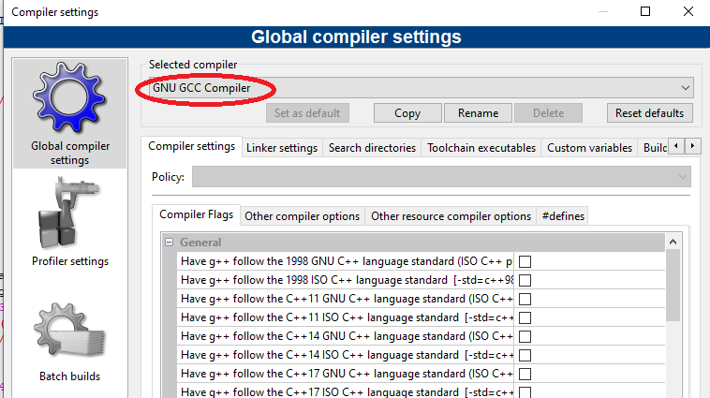

The selected compiler should be ”GNU GCC Compiler”, if not, select it from the list and select “Set as default” option.

* Choose Ok in that window.

* In the main part of the program, you will find three buttons to compile and run the code



The “wheel” compiles the code, “play” run the code, and “wheel + play” compiles and run the code.

And that’s all!

**2) Ubuntu**

**Installing GCC on Ubuntu:**

* Start by updating the packages list: sudo apt update.

* Install the build-essential package by typing: sudo apt install build-essential. ...

* To validate that the GCC compiler is successfully installed, use the gcc --version command which prints the GCC version: gcc --version.

**Running the code:**

* Place in the folder where the code is in.

* To compile the code write: gcc -march=native -o executablename KMC-LiC-Version1.cpp -lm

-march=native is a flag to adequate the code to the micro-architecture of -your computer.

-lm is a flag to compile a code that uses the library math.h

* An executable file will be generated with the name executablename.

* Run the executable with the order ./executablename